Smell Test Partner Toolkit
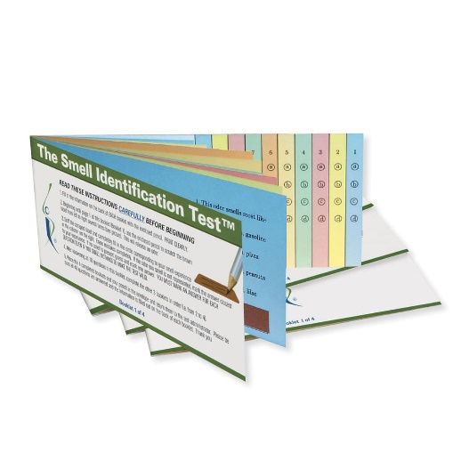
Description of Smell Test

The UPSIT (University of Pennsylvania Smell Identification Test) is a simple, safe, scratch-and-sniff test that you can do in the comfort of your own home. This smell test is a validated and reliable tool trusted by doctors and scientists. It is considered the “gold standard” to check your sense of smell.
The smell test consists of four 10-page booklets with 40 questions total. Each page has a different scratch-and-sniff strip and the scent (such as gasoline or pizza) is released by using a pencil. There are four multiple-choice options to choose from. The test is scored out of answers to the 40 items. The score determines sense of smell function with different levels (e.g., from mild to severe). The smell test takes about 15 minutes to complete.
How-to
- Complete smell test with multiple-choice options
- Enter answers online
- Study team will review your results
- Results may mean you’re a good candidate for a brain health study
References and Image Credit
- Doty, Richard L., Kamath, Vidyulata, The influences of age on olfaction: a review. Frontiers in Psychology. doi: 10.3389/fpsyg.2014.00020. Link to source.
- Sensonics International. Smell Identification Test™ (UPSIT®). Link to source.

